Azure Log Analytics Workspace – Monitoring 21/04/2026

To deploy monitoring for an azure kubernetes service you need to have a ‘log analytics workspace’ set up and then you can deploy monitoring with respect to that workspace.

https://www.youtube.com/watch?v=kJjBr0ppPy0
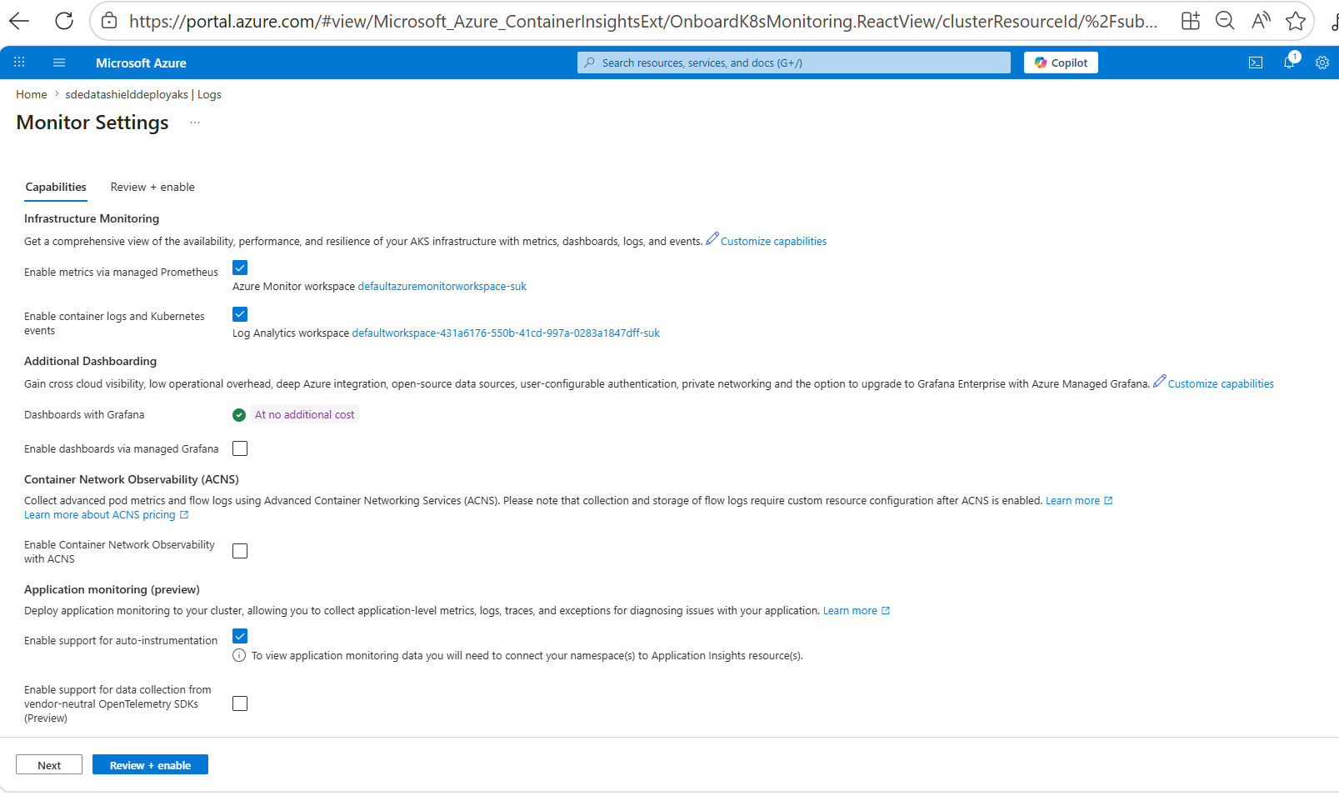

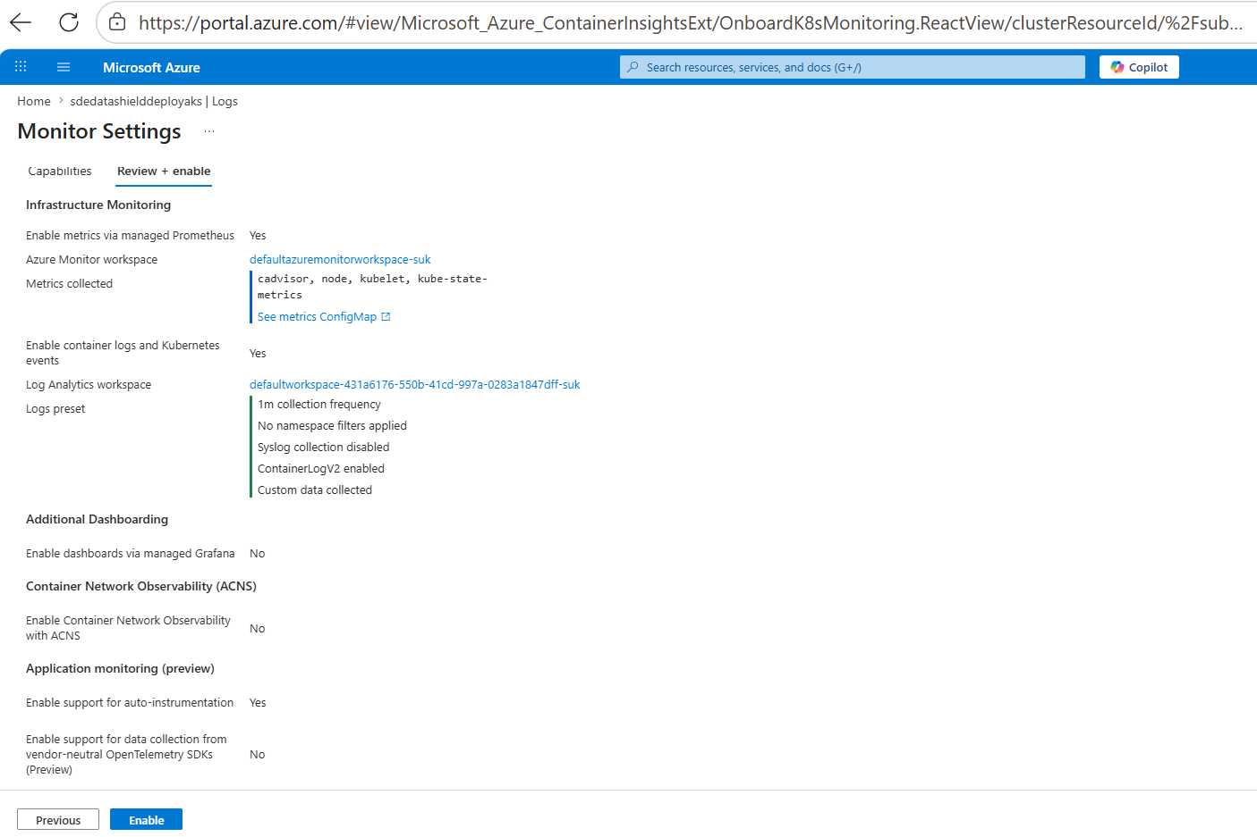

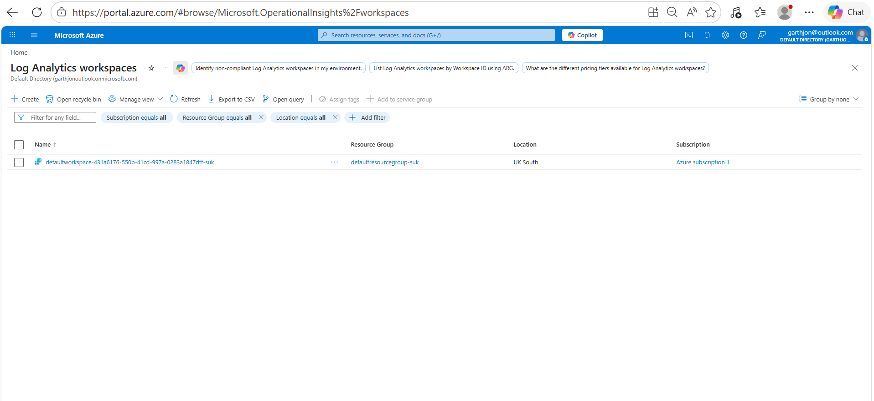

running a query in log analytics to check the health of the OPAL POD –

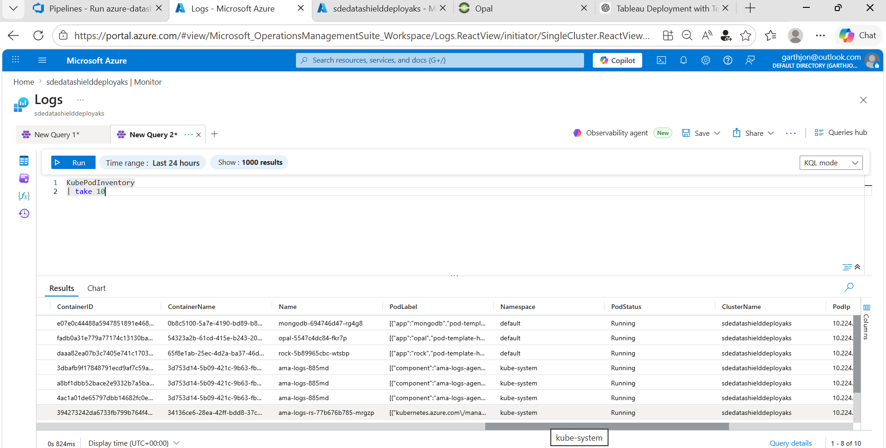

- this query selects the top 10 rows of the table kubePODinventory

KubePodInventory
| take 10

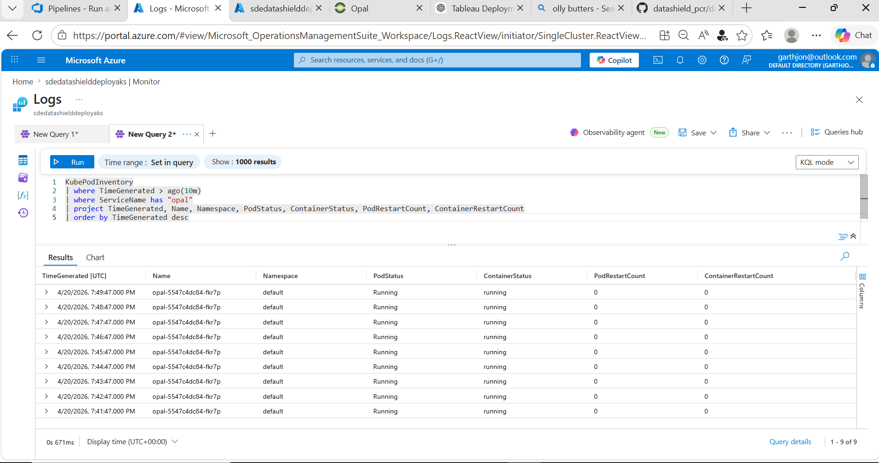

KubePodInventory
| where TimeGenerated > ago(10m)
| where ServiceName has "opal"
| project TimeGenerated, Name, Namespace, PodStatus, ContainerStatus, PodRestartCount, ContainerRestartCount
| order by TimeGenerated desc

the podstatus and the container status seem fine

checking the container log in loganalytics

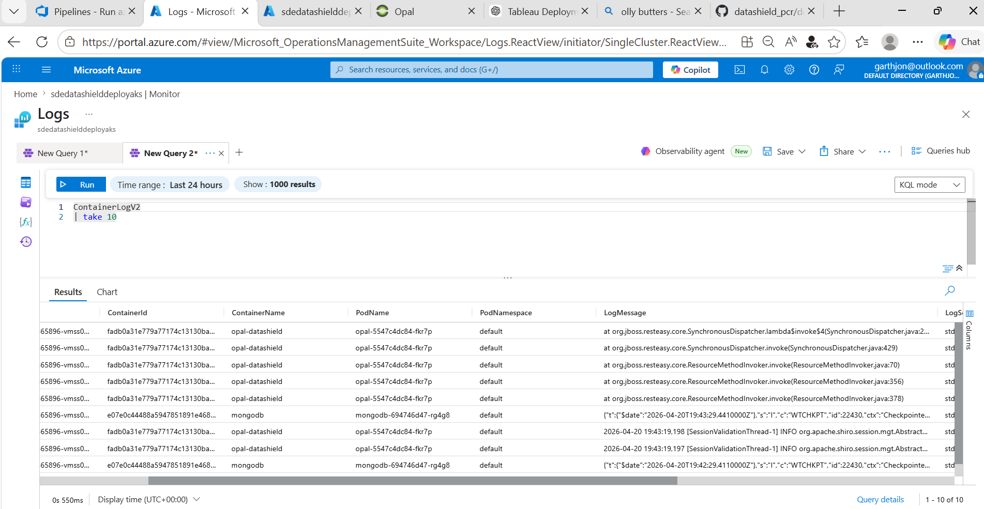

ContainerLogV2
| take 10

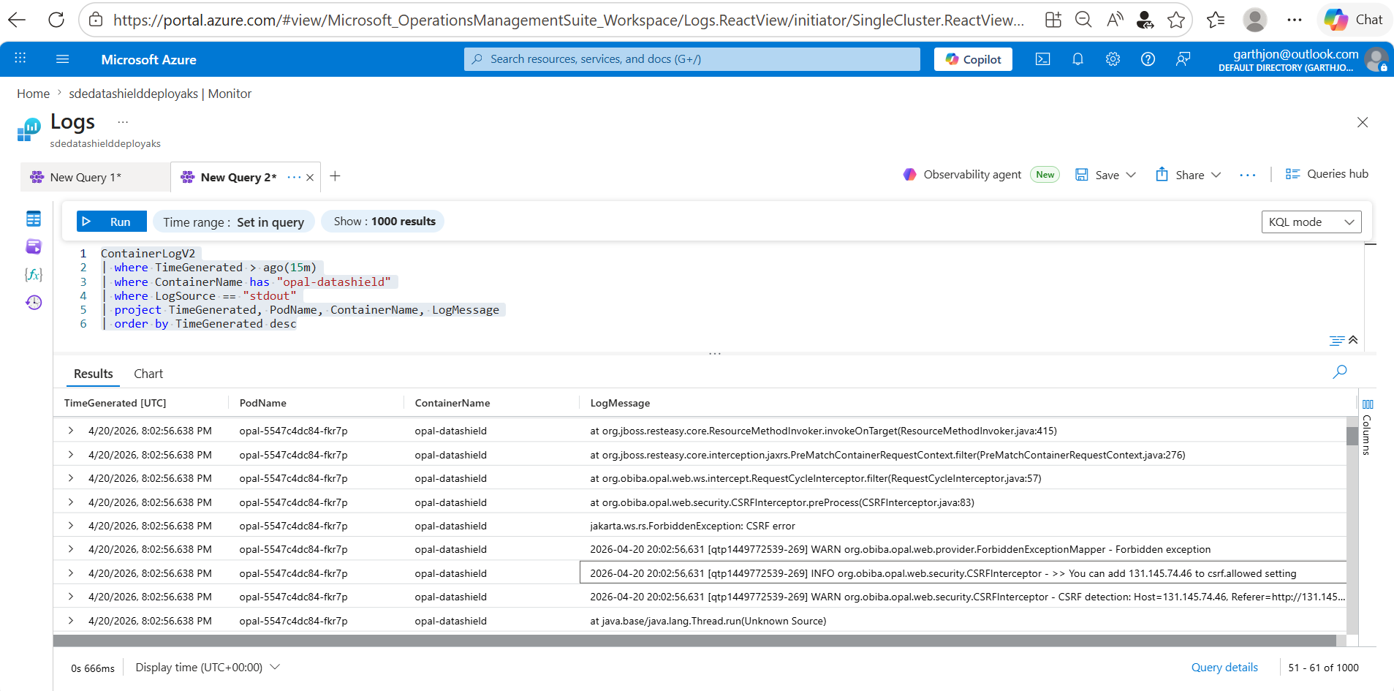

ContainerLogV2
| where TimeGenerated > ago(15m)
| where ContainerName has "opal-datashield"
| where LogSource == "stdout"
| project TimeGenerated, PodName, ContainerName, LogMessage
| order by TimeGenerated desc

Updating the yaml deployment file manually with the external ip address for the CSRF ‘allowed’ value. N.b. manual work around is not ideal but will do for now

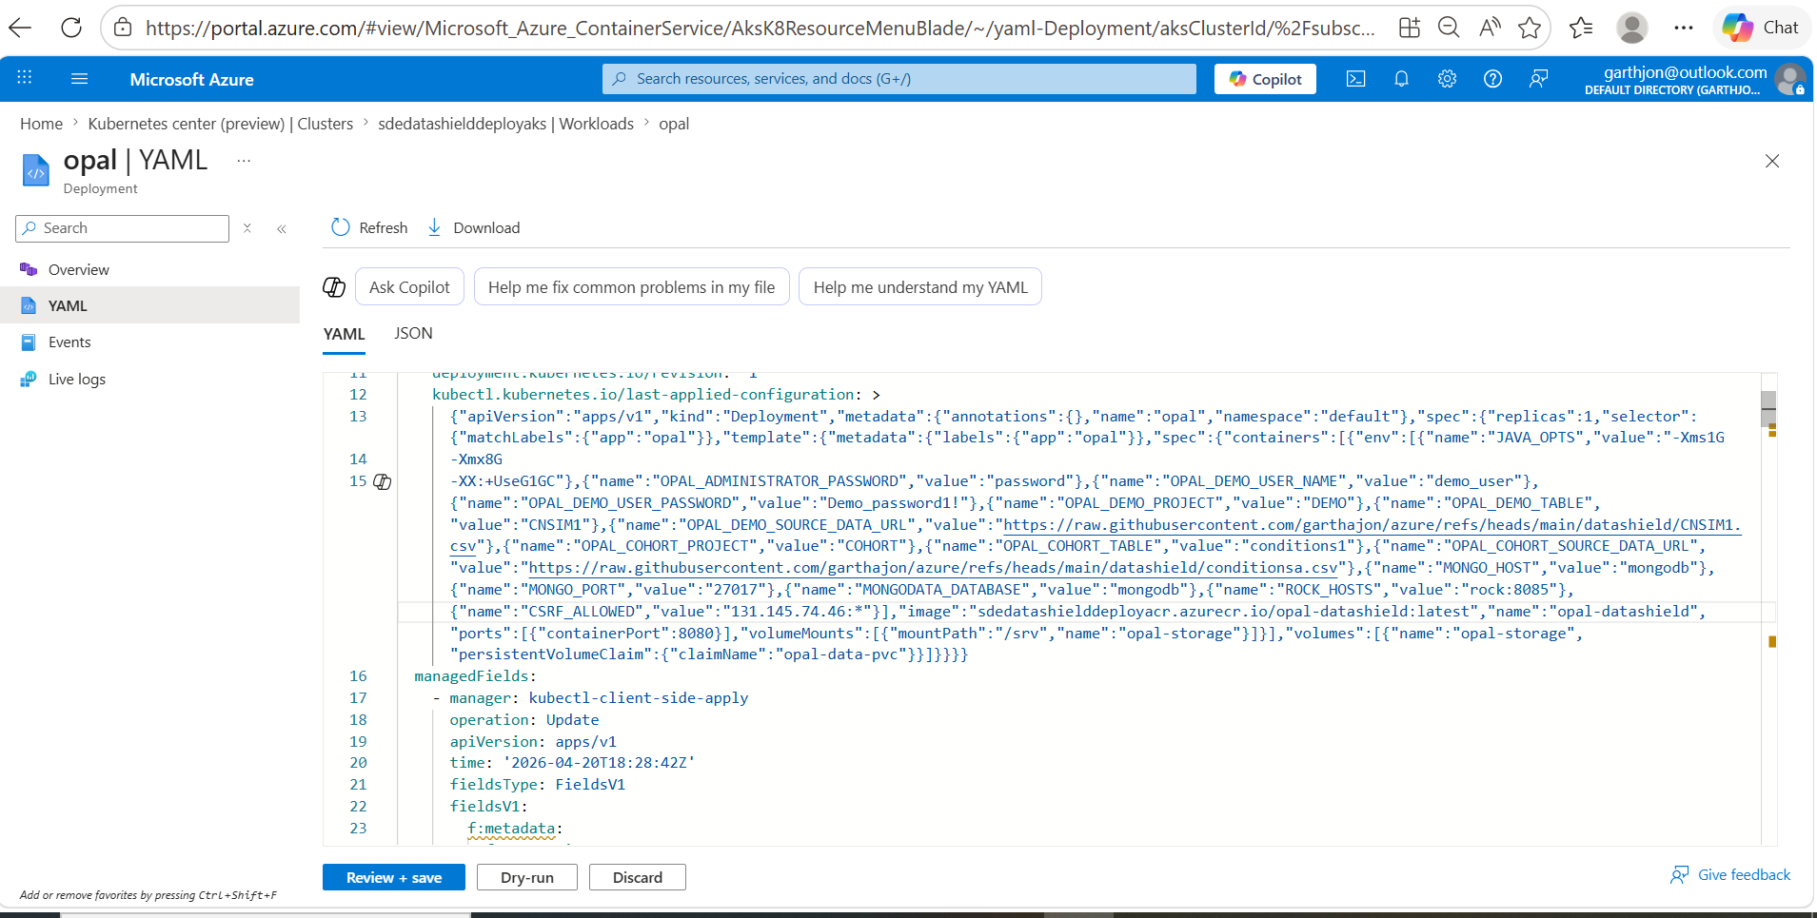

confirming the change –

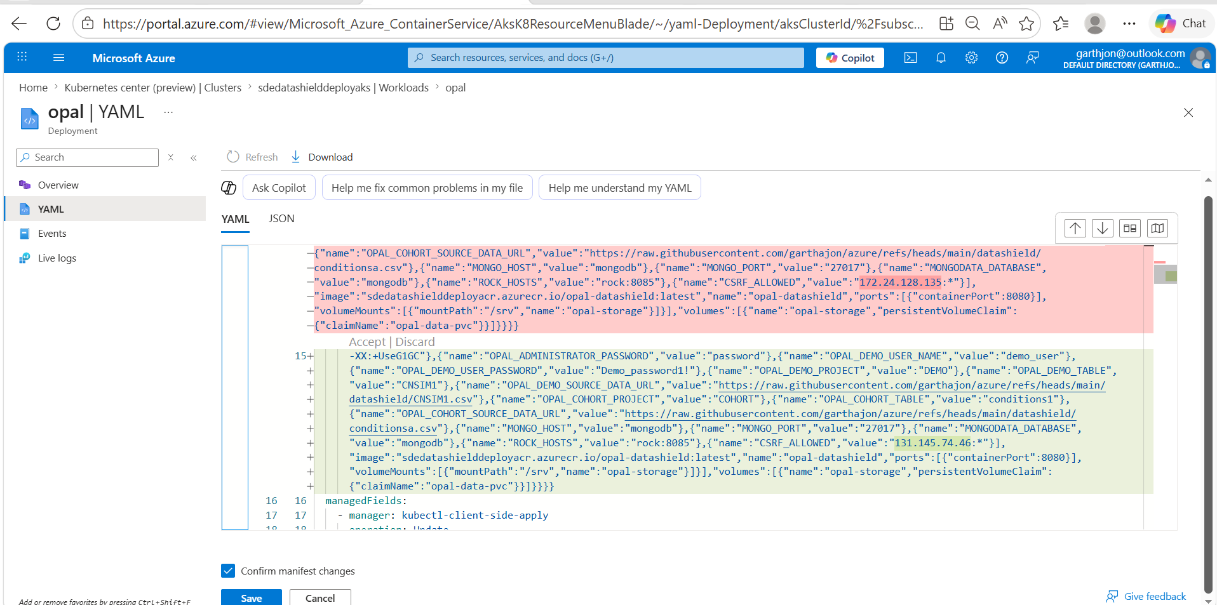

I had to stop and start the user node pool for the change to take effect

